

**EXPERIMENT NO:06**

**Aim:** Sketch Sequence and Collaboration Diagram for Our Project

**Tools:** IBM Rational Rose

**Theory:**

Sequence diagrams are a popular dynamic modelling solution in UML because they specifically focus on *lifelines*, or the processes and objects that live simultaneously, and the messages exchanged between them to perform a function before the lifeline ends. Along with our UML diagramming tool, use this guide to learn everything there is to know about sequence diagrams in UML.To understand what a sequence diagram is, it's important to know the role of the Unified Modelling Language, better known as UML. UML is a modelling toolkit that guides the creation and notation of many types of diagrams, including behavior diagrams, interaction diagrams, and structure diagrams.A sequence diagram is a type of interaction diagram because it describes how—and in what order—a group of objects works together. These diagrams are used by software developers and business professionals to understand requirements for a new system or to document an existing process. Sequence diagrams are sometimes known as event diagrams or event scenarios.  
Note that there are two types of sequence diagrams: UML diagrams and code-based diagrams. The latter is sourced from programming code and will not be covered in this guide. Lucid chart’s UML diagramming software is equipped with all the shapes and features you will need to model both.

Sequence diagrams can be useful references for businesses and other organizations. Try drawing a sequence diagram to:

* Represent the details of a UML use case.
* Model the logic of a sophisticated procedure, function, or operation.
* See how objects and components interact with each other to complete a process.
* Plan and understand the detailed functionality of an existing or future scenario.

**Use cases for sequence diagrams**

The following scenarios are ideal for using a sequence diagram:

* Usage scenario: A usage scenario is a diagram of how your system could potentially be used. It's a great way to make sure that you have worked through the logic of every usage scenario for the system.
* Method logic: Just as you might use a UML sequence diagram to explore the logic of a use case, you can use it to explore the logic of any function, procedure, or complex process.
* Service logic: If you consider a service to be a high-level method used by different clients, a sequence diagram is an ideal way to map that out.
* Sequence diagram Visio - Any sequence diagram that you create with Visio can also be uploaded into IBM Rational Rose. IBM Rational Rose supports.vs. and .vex file import and is a great Microsoft Visio alternative. Almost all of the images you see in the UML section of this site were generated using IBM Rational Rose.

**Common message symbols**

Use the following arrows and message symbols to show how information is transmitted between objects. These symbols may reflect the start and execution of an operation or the sending and reception of a signal.

| Symbol | Name | Description |
| --- | --- | --- |
|  | Synchronous message symbol | Represented by a solid line with a solid arrowhead. This symbol is used when a sender must wait for a response to a message before it continues. The diagram should show both the call and the reply. |
|  | Asynchronous message symbol | Represented by a solid line with a lined arrowhead. Asynchronous messages don't require a response before the sender continues. Only the call should be included in the diagram. |
|  | Asynchronous return message symbol | Represented by a dashed line with a lined arrowhead. |
|  | Asynchronous create message symbol | Represented by a dashed line with a lined arrowhead. This message creates a new object. |
|  | Reply message symbol | Represented by a dashed line with a lined arrowhead, these messages are replies to calls. |
|  | Delete message symbol | Represented by a solid line with a solid arrowhead, followed by an X. This message destroys an object. |

**Collaboration Diagram:**

A collaboration diagram, also known as a communication diagram, is an illustration of the relationships and interactions among software objects in the Unified Modelling Language (UML). These diagrams can be used to portray the dynamic behavior of a particular use case and define the role of each object.

Collaboration diagrams are created by first identifying the structural elements required to carry out the functionality of an interaction. A model is then built using the relationships between those elements. Several vendors offer software for creating and editing collaboration diagrams.

**Notations of a collaboration diagram**

A collaboration diagram resembles a flowchart that portrays the roles, functionality and behavior of individual objects as well as the overall operation of the system in real time. The four major components of a collaboration diagram are:

1. Objects- Objects are shown as rectangles with naming labels inside. The naming label follows the convention of object name: class name. If an object has a property or state that specifically influences the collaboration, this should also be noted.
2. Actors- Actors are instances that invoke the interaction in the diagram. Each actor has a name and a role, with one actor initiating the entire use case.
3. Links- Links connect objects with actors and are depicted using a solid line between two elements. Each link is an instance where messages can be sent.
4. messages- Messages between objects are shown as a labelled arrow placed near a link. These messages are communications between objects that convey information about the activity and can include the sequence number.

The most important objects are placed in the center of the diagram, with all other participating objects branching off. After all objects are placed, links and messages should be added in between.

* **Sequence Diagram for Bank Management System**

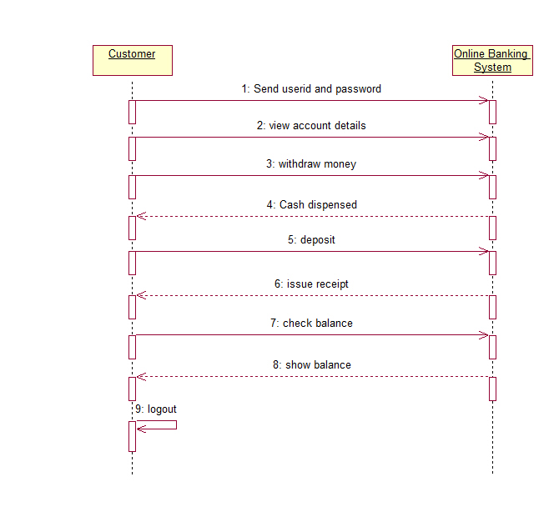

* **Collaboration Diagram for Bank Management System**

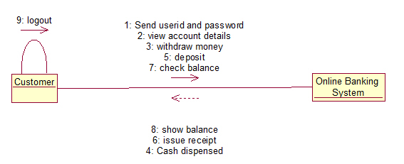

* **Conclusion:** Thus, we have successfully understood Sequence and Collaboration Diagram and how to sketch this diagram for our Project.

For Faculty Use

|  |  |  |  |  |
| --- | --- | --- | --- | --- |
| **CorrectionParameters** | **FormativeAssessment[40%]** | **Timely completionofPractical[40%]** | **Attendance /LearningAttitude[20%]** |  |
| **MarksObtained** |  |  |  |